**Name**-Tharush Upamal Senasinghe

**SLIIT ID** – IT21073878

**Exercise 01**

//Tharush Upamal Senasinghe - IT21073878 - Malabe_Group5.1

#include <studio.h>

int main()

{

printf("Tharush Upamal Senasinghe\n\n");

printf("Welcome\nTo\nSLIIT\n\n");

printf("Welcome\tto\tSLIIT\t\n\n");

printf("******** *** * * \n");

printf("* * * * ** *** \n");

printf("* * * * *** ***** \n");

printf("* * * * **** * \n");

printf("* * * * ***** * \n");

printf("******** *** ***** *");

return 0;

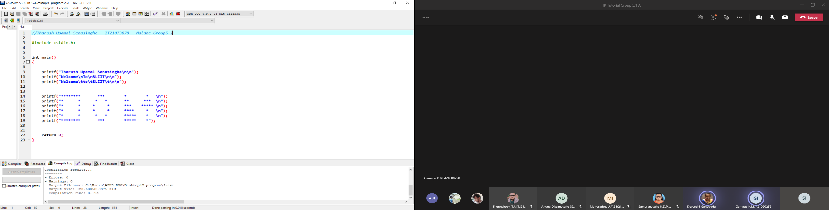}

**Exercise 02**

Created with www.genmymodel.com

**Exercise 3**

1. Input – Celsius Value

Output - Fahrenheit value

Calculation - Fahrenheit = (9/5 * Celsius) + 32

1. Input – Fare for each bus

Output - Total travel expenditure for the semester

Calculation - calculation the total expenditure

total expenditure =(sum of fare of buses) * 5 * 14* 2

1. Input - value of basic salary

Output - Bonus received

Calculation - calculation the bonus received.

Bonus = (value of basic salary) * 20/100